BRAILLE-BRIDGE
Research Case Study
Why a full page of changeable Braille is still out of reach for most blind readers, and how a passive-pin device with a shared writer can bring it within reach, starting in Bangladesh.
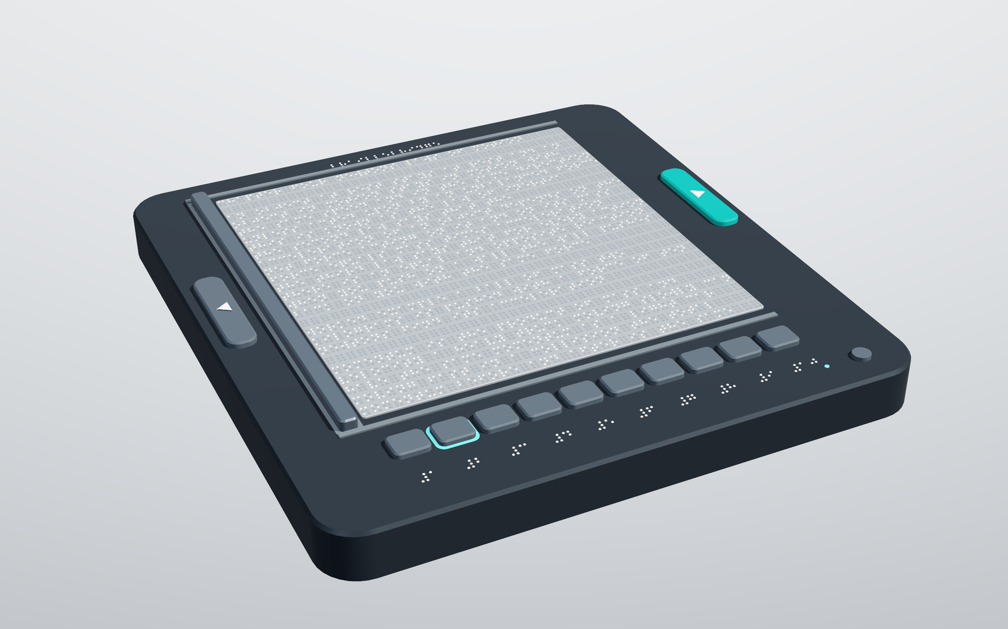

Item | Detail
Document | Research Case Study, BrailleBridge 2
Research question | Can passive pins and a shared writer put a whole page of Braille in reach of most blind readers?
Hardware status | Working hardware prototype (Mini V0), plus a full-page tablet design modelled in 3D
Full-page design | 40 cells by 25 lines of real-size Braille on one surface, with ten one-press book slots
Focus regions | Bangladesh first, then the world
Author contact | yeasrsamin20@gmail.com
Related work | BrailleBridge 1, a 6-key chording keyboard (github.com/Solez-ai/braille.bridge)
Date | 24 October 2026

1. The Problem
Braille is how many blind people read and write, and it is tied to literacy and employment. Yet a reader who wants a whole page of Braille, such as a textbook page, a form or a PDF from a phone, has very few options. Embossed paper is made once and cannot be updated. A refreshable display shows one line of 14 to 40 cells and is priced out of reach for most families.
The scale of need is large. The World Health Organization reports at least 2.2 billion people with vision impairment or blindness, and at least 1 billion of those cases are preventable or unaddressed. Blindness rates in South Asia and sub-Saharan Africa are about eight times those of high-income regions [1]. The Global Burden of Disease analysis estimates 43.3 million blind people in 2020, and South Asia has the largest number, about 11.9 million [2].
Measure | Value | Source
People with vision impairment or blindness, world | 2.2 billion or more | WHO, 2019 [1]
Blind people, world, 2020 | 43.3 million | GBD [2]
Blind people, South Asia, 2020 | about 11.9 million | GBD [2]
Adults 40+ blind, Bangladesh | about 1.0% | BMJ Open, 2013 survey [3]
People with disabilities, Bangladesh | 4.62 million (2.8%) | BBS survey via TBS News [4]
Braille textbooks distributed, one 2020 report | 9,504 | Prothom Alo [5]

Disability and blindness figures vary between surveys because they use different definitions. They are shown here to give the scale, not as exact counts.
Why this matters. In the United States, about 90 percent of employed blind adults are Braille readers [8]. That is a correlation, not proof of cause, but it shows why Braille access is treated as a literacy issue and not a convenience.

2. Research Question and Why Existing Answers Fall Short
Research question. Can a device raise and lower the dots of a whole page of Braille, taken from a phone, a book or a PDF, without an actuator under every dot?
Hypothesis. If each dot is held by friction and only the act of changing a dot needs energy, then the number of actuators can be made independent of the number of dots. Cost then scales with the writer, not the page. The trade is time: a shared writer visits the dots instead of every dot having its own actuator, and adding writers shortens the page time.
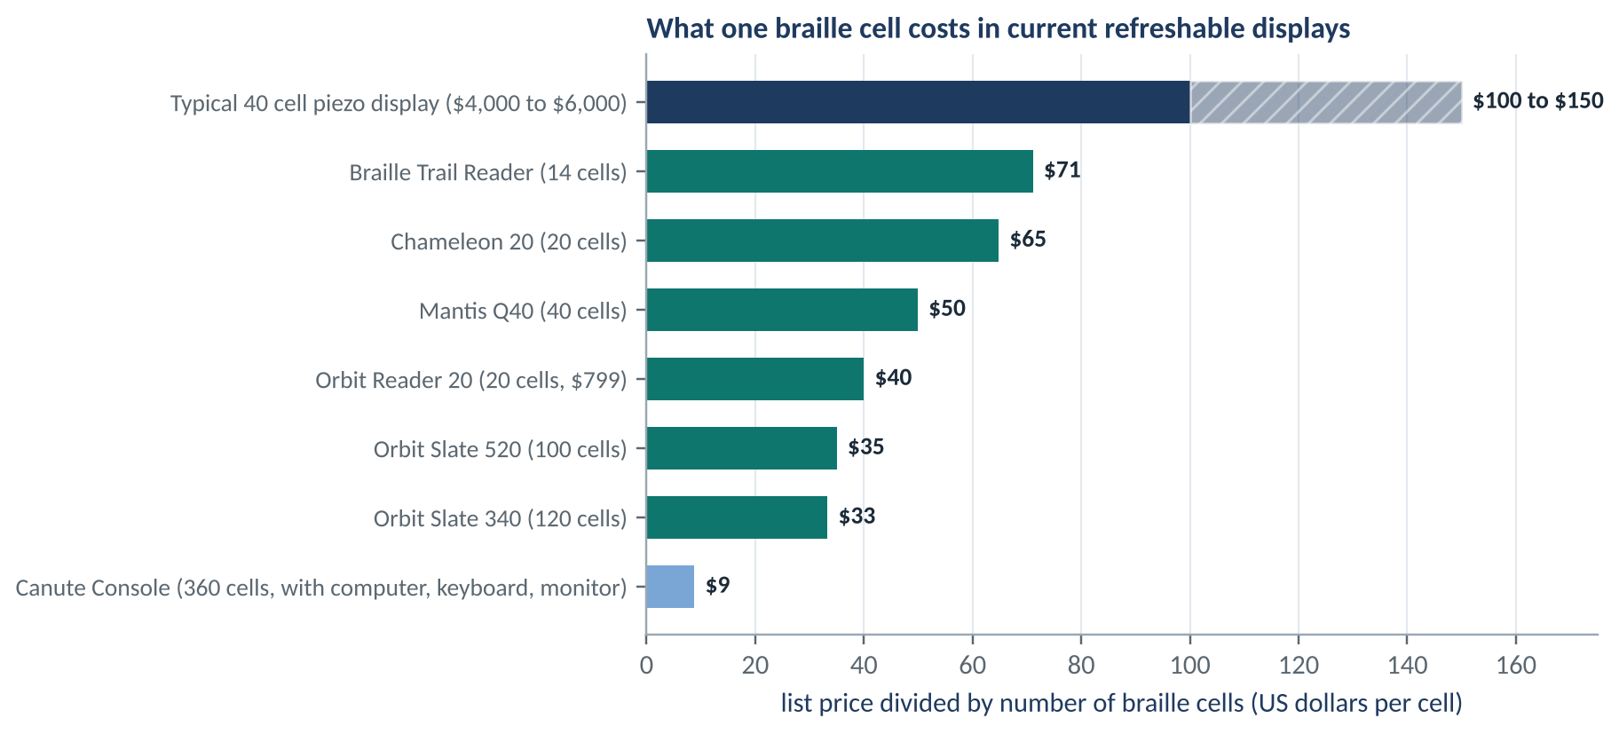
Figure 1. Cost per Braille cell of devices on the market, from published list prices. Prices were taken on different dates and change.
Device | Cells | List price | Note
Orbit Reader 20 | 20 | $799 | Single line, about $40 per cell [6]
Chameleon 20 | 20 | $1,295 | Single line [6]
Mantis Q40 | 40 | $1,995 | Single line with keyboard [6]
Orbit Slate 340 | 3 x 40 | $3,995 | Introductory price, multi-line [7]
Canute 360 | 9 x 40 | about 2,495 GBP | Nine lines, mechanical [9]
40 cell piezo displays | 40 | $4,000 to 6,000 | One piezo element per dot [10]

Related work and what is distinct here. Refreshing passive pins with a shared actuator is an active research direction. BrailleCursor (Leonardis, Loconsole and Frisoli, Meccanica 2020) moves a single actuator under passive ferromagnetic pins [14], and MagnePins (Monash University, UIST 2025) uses a carriage of staggered electromagnets with 3D-printed locking channels [15]. Together they show that a shared writer can refresh a Braille surface. BrailleBridge 2 builds on that idea in a different direction: pins held by friction in a plate and lifted by servo levers, with no magnets, so the build uses parts available in Bangladesh. The full-page design adds a comb of one pusher per line that writes every line at once, a single reset bar, and ten one-press book slots with an offline library. To our knowledge this combination has not been published; a formal patent search is planned before filing. The Canute shows that multi-line mechanical Braille is possible; BrailleBridge 2 aims to lower its cost per cell by sharing actuators.

How the main technologies compare
Technology | How a dot moves | Strength | Limit
Embossed paper | Pressed once into paper | Cheap per copy, durable | Cannot change; bulky; needs a press
Piezo cells | One bending crystal per dot | Fast, quiet, proven | Cost grows with every dot
Solenoids or motors per dot | One electromagnet per dot | Simple to drive | Large, hot, costly at scale
Mechanical multi-line (Canute) | Shared mechanism moves rows | Nine lines at modest price | Complex, still costly
BrailleBridge 2 | Passive pins, shared writer | Few actuators, holds without power | Page takes minutes, not instantly

3. The BrailleBridge 2 Approach
The idea is a change of where the energy goes. In a conventional cell every dot has its own actuator, so the cost grows with every dot. In BrailleBridge 2 the dots are passive. A pin stays up or down by friction. A small head moves along the page, stops over each dot that must rise, and lifts it. A single plate then lowers everything when a new page begins.
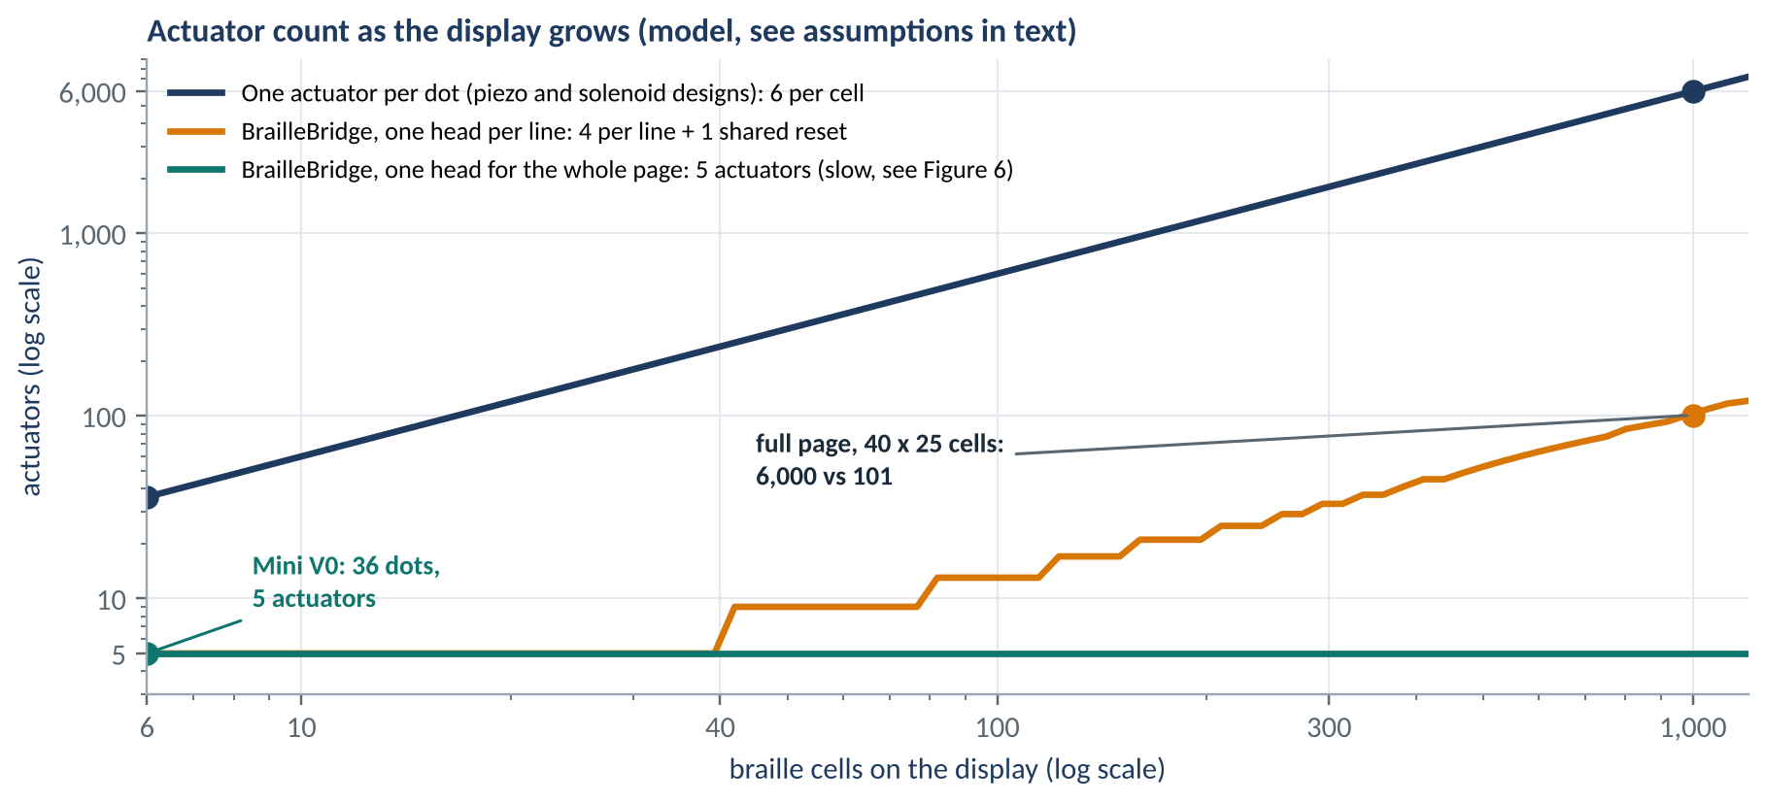
Figure 2. Actuator count: conventional per-dot design against the moving-head design.
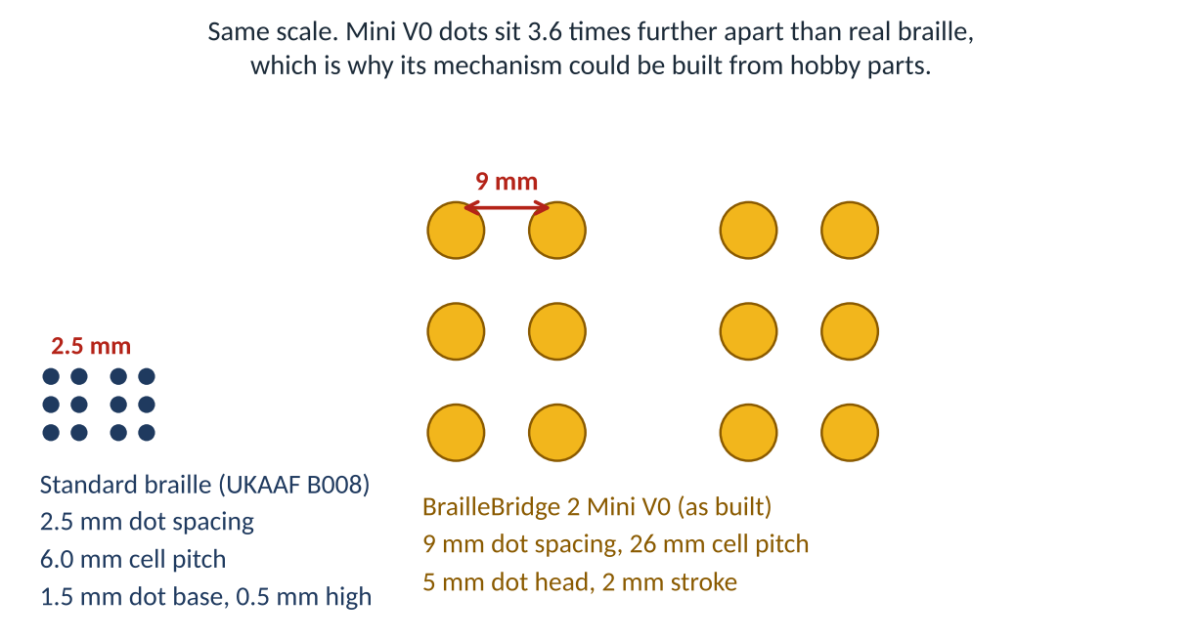
Figure 3. Real Braille dots (left) against the Mini V0 dots (right) at the same scale. The mechanism is proven at 3.6 times real size.
- Few actuators: Mini V0 uses 5 in total for 36 pins. A conventional design needs 36.
- Power-free memory: a written page stays readable with the supply off.
- Speed by parallel writing: one head visits every dot in turn, so the full-page design writes every line at once with a comb of pushers.

4. What Has Been Built
Mini V0 is the working hardware proof of the mechanism: a complete writer and display that takes text from a phone and writes it in raised dots, using off-the-shelf parts.
Part | Specification
Display | 6 cells by 1 line, 36 friction-latched pins, 2 mm stroke
Writer head | 3 SG90 servo finger levers on a stepper-driven carriage
Carriage | 28BYJ-48 stepper, printed rack and pinion, 72.08 half-steps per mm
Reset | MG90S servo and crank lowering one reset plate
Controller | ESP32 with its own Wi-Fi access point; no internet or app needed
Input | Web console that encodes text to UEB grade 1; NEXT and PREV switches
Build | Fully 3D printed parts in PLA with off-the-shelf hobby electronics

The prototype uses a 9 mm dot spacing and 26 mm cell pitch, which is 3.6 times larger than standard Braille. This is on purpose: large parts print reliably on a hobby printer. The research value is the mechanism, which does not depend on the size. Section 8 describes what shrinking it requires.
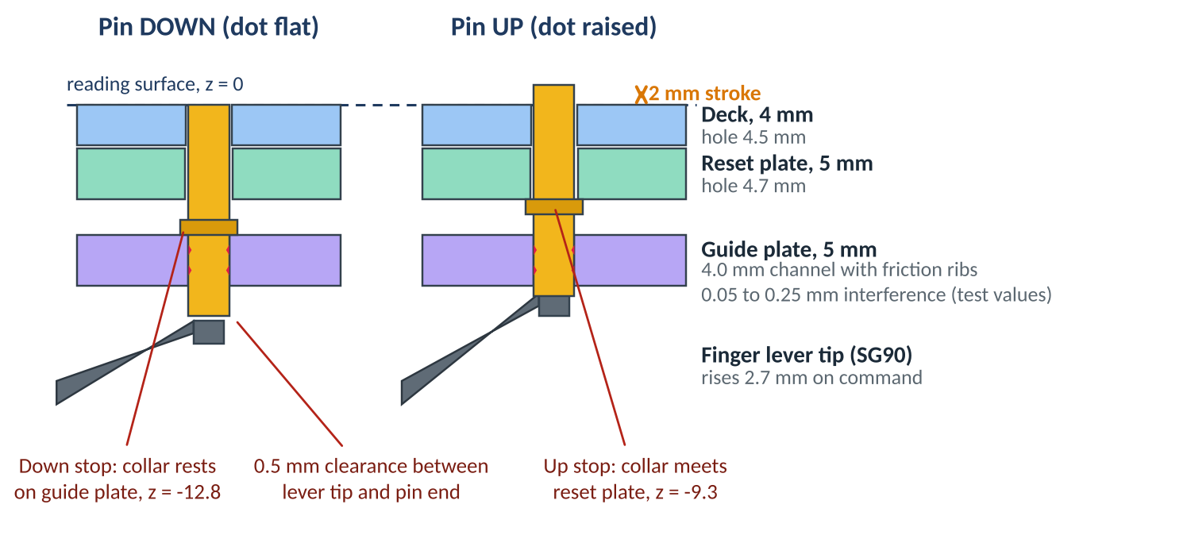
Figure 4. Section through one pin of the prototype in its two states.
Timing figures in this document are design values taken from the firmware constants. Bench measurement is the first step of the evaluation plan in Section 9.

5. A Bangladesh Perspective
In Bangladesh the shortage is of material as much as of devices. Press reports describe Braille books as scarce, with the government distributing 9,504 Braille textbooks in one 2020 round [5], and a university resource centre holding only a few dozen Braille books [5]. The WIPO Accessible Books Consortium describes a global book famine in which very few published titles exist in accessible form [11]. Bangladesh has ratified the Marrakesh Treaty, which allows accessible copies to be made and shared across borders, but a copy still needs a way to be read.
- Offline by design: the device makes its own Wi-Fi network, so a school without internet can still use it.
- Resilient to power cuts: pins hold their state without power, so a written page survives load-shedding.
- Local repair: parts are printed plastic, hobby servos and a common microcontroller that can be bought and replaced locally.
- Bangla Braille: Bangla uses the same six-dot cell, so the mechanism is unchanged. The current console encodes English UEB grade 1 only, and Bangla encoding is the next software step.
- Target cost: Mini V0 was designed to cost 2,000 to 3,000 taka in parts; a parts audit is part of the evaluation plan.

6. A Global Perspective
The same mechanism matters wherever a refreshable page is too costly: schools in South Asia and sub-Saharan Africa, where blindness is most common and budgets are smallest [1]; libraries that cannot buy many displays; and anywhere a blind student needs a diagram, a graph or a table, which a single line cannot show. Multi-line displays are already described by the American Foundation for the Blind as an important unmet need [12].
Braille literacy has also fallen. In the United States about half of legally blind children read Braille in 1960, against about 10 percent in 1998 to 1999 [8]. A device that makes Braille cheaper to produce and easier to refresh targets one of the causes of this decline: the cost and scarcity of material.

Who could benefit
Group | Need | What the device offers
Students | Textbook pages, tables, graphs | A full page that can be changed for each lesson
Schools and libraries | Many readers, few displays | One shared low-cost device per class
Adults who lose sight later | Learning Braille at home | Private practice on any text
Teachers and makers | Repair and adapt | Open parts and files, local printing

Scope of the claim. The claim is about cost structure: a shared writer makes a full page of changeable Braille cheaper to build. Effects on literacy would be studied with readers once a full-size device exists.

7. The Full-Page Tablet
The full-page design is a flat tablet with one reading surface of real-size Braille. Standard dimensions are 2.5 mm dot spacing, 6.0 mm cell pitch, 10 mm line spacing and a dot height of about 0.5 mm [13]. A page of 40 cells by 25 lines is 1,000 cells and 6,000 dot positions, comparable to a standard Braille page. Under the plate, one comb bar carries 25 pushers, one per line, and steps across the page so that every line is written at the same time. A reset bar parks in a side bay and flattens the page when it is rewritten.
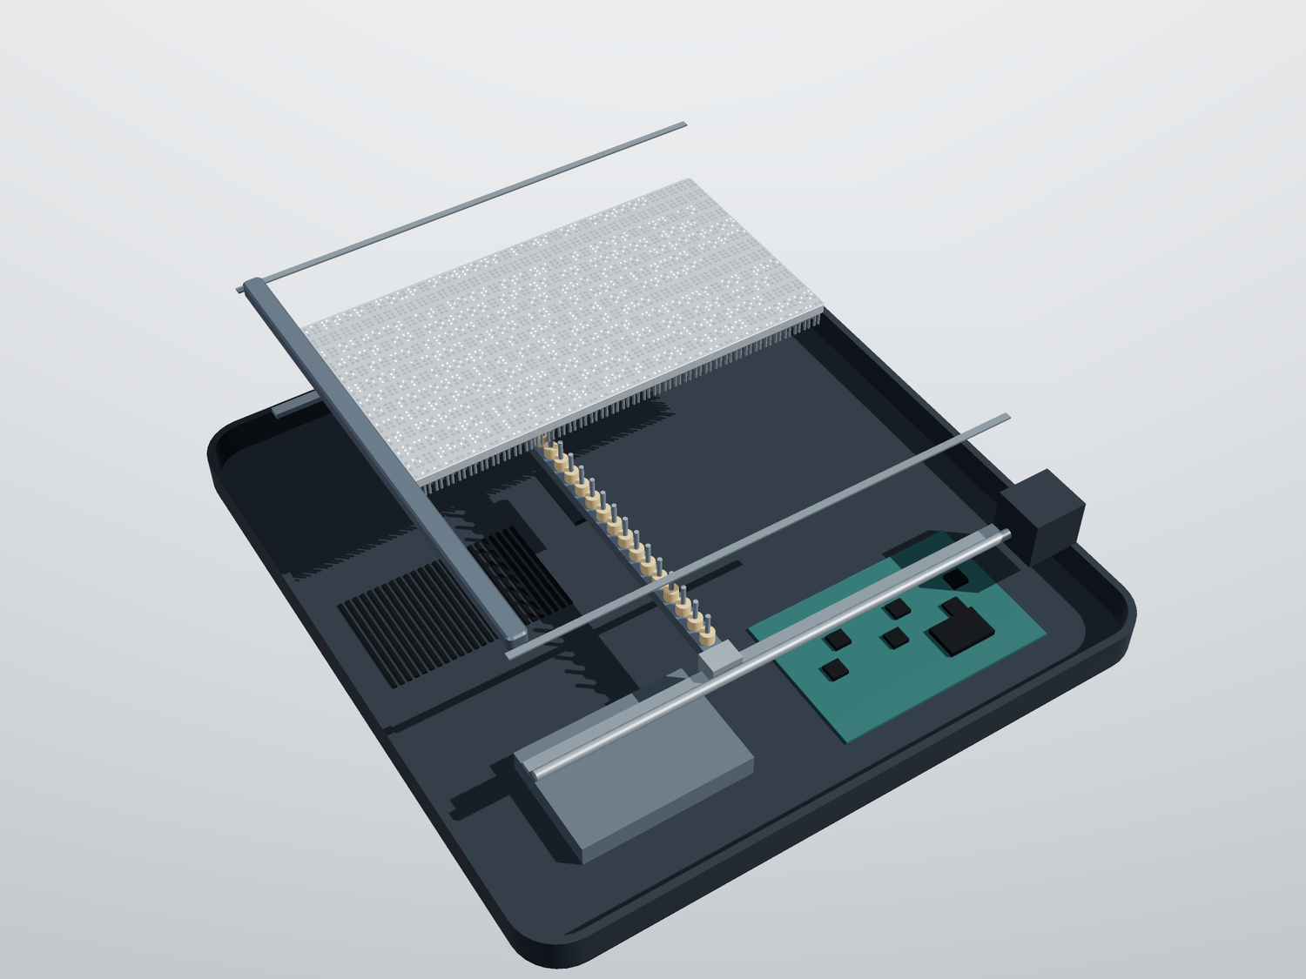
Figure 5. Cutaway of the tablet design (3D model). Left to right through the layers: base tray with electronics, comb bar with 25 pushers on a lead screw, pin plate (rear half shown) with pins, and the reset bar lifted above the plate. The top shell is not shown.
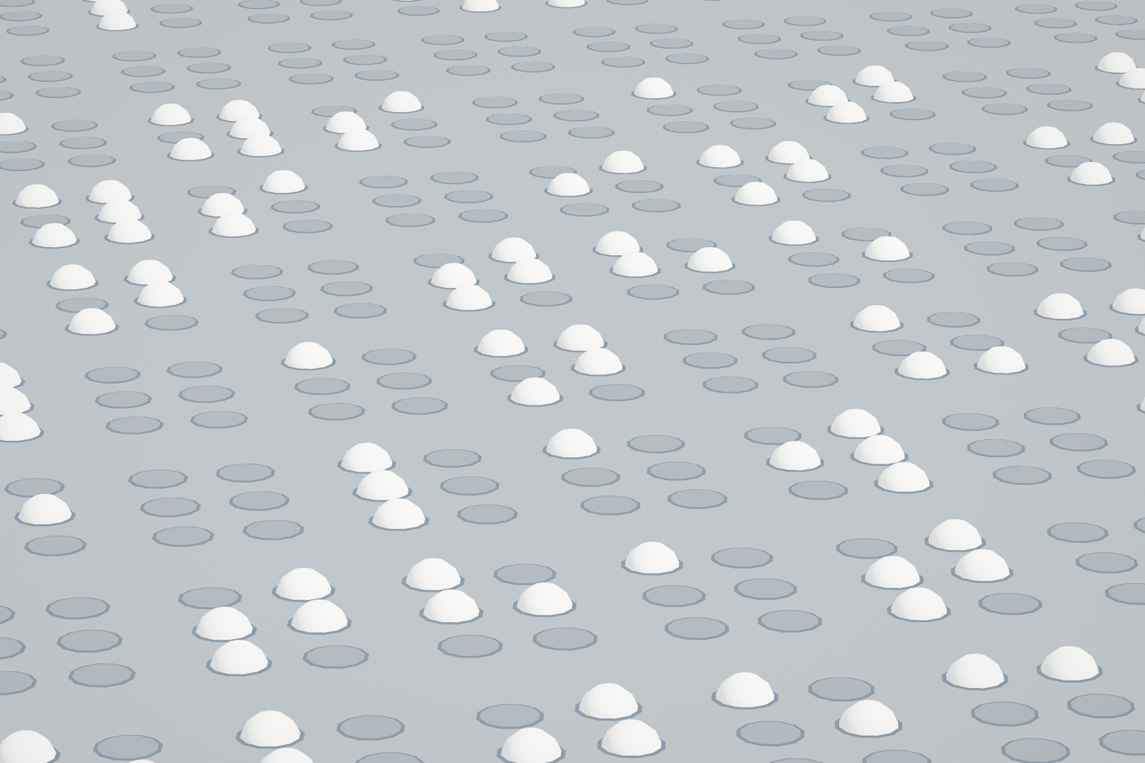
Figure 6. Real-size Braille on the modelled plate: raised dots are 1.5 mm across and 0.6 mm high on a 2.5 mm grid; the flush pin tops show where a dot can rise.
- Ten slots, one press: each slot button, marked with a tactile Braille number, opens its own book or text at the page where the reader stopped.
- Whole-page reading: the reader explores a table, map or equation with both hands.
- Offline library: books and PDFs are sent from a phone over the tablet's own Wi-Fi and stored on the device.
The renders are a concept model. Body thickness and the internal stack are indicative and are fixed by the build plan, not yet by testing.

8. Scaling Model and Open Problems
The numbers below are model values, not measurements. They assume the firmware speed of 500 half-steps per second (6.94 mm per second), 0.25 s per raised dot, an average of 2.79 raised dots per cell taken from the sample text, and a 240 mm line.
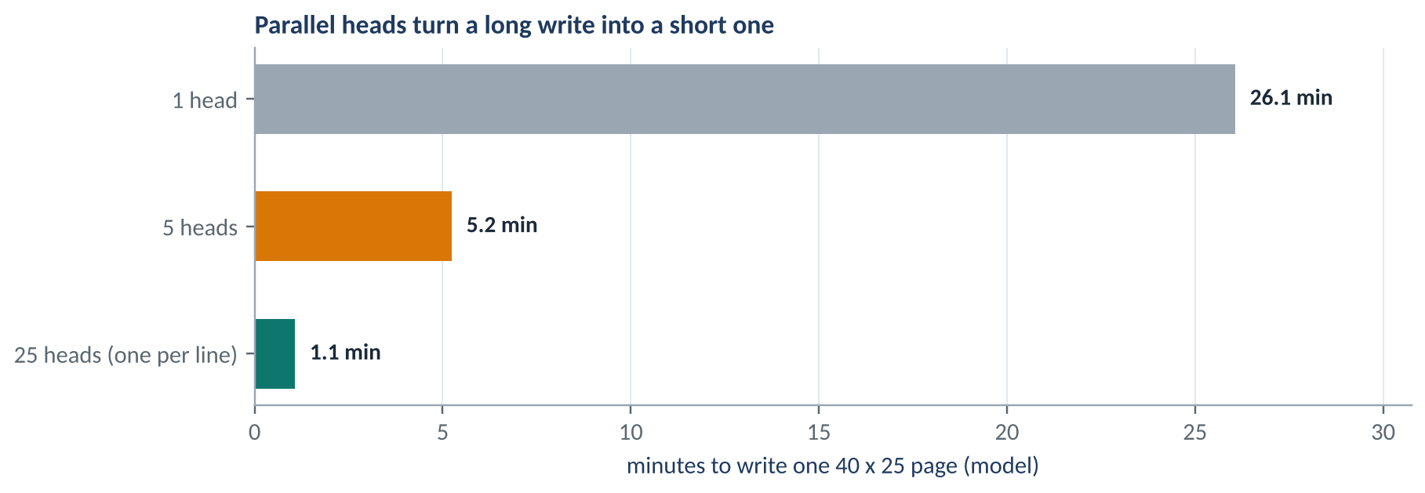
Figure 7. Modelled time to write a 40 by 25 page with one head, five heads and one head per line.
Design | Heads | Actuators | Page time
One head | 1 | 5 | 26.1 min
Five heads | 5 | about 25 | 5.2 min
One head per line | 25 | 101 | 1.1 min
Comb bar, one pusher per line (tablet design) | 1 bar | 28 | about 3 min
Conventional per-dot (comparison) | none | 6,000 | about instant

The comb bar row is an estimate: 25 pushers plus three motors, 3 row passes of 80 stops, at an assumed 0.75 s per stop. It will be replaced by a measured value.

Open engineering problems
- Finger pitch: real Braille needs a 2.5 mm dot spacing, so fingers and pins must be thinner by a factor of about 3.6.
- Pin size: pins of about 1.5 mm and a dot height of about 0.5 mm need new guide materials and friction control.
- Flatness: plates must stay flat over about 240 by 250 mm.
- Wear and drift: without a position sensor the head may drift over long runs.
- Retention: friction must hold a dot against a reading finger yet release for a reset.
- Reset force: the reset bar must flatten every raised dot of a page; the force needed is measured on a test plate first.

9. Evaluation Plan
Question | Measurement | Success sign
Does the pin hold? | Force to push a raised dot down, 100 samples | Above a reading touch force, every pin
Is height repeatable? | Dot height over 1,000 page writes | Within the standard tolerance
Does position drift? | Stop position error over 50 pages | No missed dot
How long is a page? | Stopwatch for 20 pages against the model | Within 10 percent of the model
Can people read it? | Reading test with Braille readers at 3.6 times scale | Accuracy and comfort reported
Cost | Audited parts list in taka | At or under the target

The reading test should involve blind Braille readers from the start, with consent and ethical review where required. Their feedback decides which direction the project takes.

10. Conclusion and References
BrailleBridge 2 asks whether the cost of changeable Braille is a physics problem or a design problem. The working prototype suggests it can be a design problem: a passive-pin page and a moving head already write text on a desk. The next stage is to prove it at real Braille size, and the plan above sets out how.

Next steps
- Measure: run the evaluation plan on Mini V0 and publish the results.
- Localise: add Bangla Braille encoding to the console and test with Bangladeshi readers.
- Shrink: build a single-line module at real Braille spacing to test the finger-pitch problem.
- Share: release files and a build guide once the author has decided how to protect the design.

References. [1] WHO, first World report on vision, 8 Oct 2019, who.int. [2] GBD Vision Loss Expert Group, PMC7820390. [3] BMJ Open 2022, Bangladesh blindness survey, PMC8977819. [4] TBS News, BBS disability survey, tbsnews.net/node/558590. [5] Prothom Alo, Braille books scarce in Bangladesh, en.prothomalo.com. [6] Orbit Research product pages and the APH Refreshable Braille Comparison, in.gov/isbvi. [7] Orbit Slate announcement, Jan 2024. [8] Braille literacy, Wikipedia. [9] Canute, Bristol247 and Bristol Braille Technology. [10] Alam et al. 2024, cited in an NHSJS paper, nhsjs.com. [11] WIPO Accessible Books Consortium, wipo.int/abc. [12] AFB, Spotlighting multi-line displays, afb.org. [13] UKAAF, Braille Standard Dimensions (B008), ukaaf.org. [14] D. Leonardis, C. Loconsole, A. Frisoli, A passive and scalable magnetic mechanism for braille cursor, Meccanica 55, 2020, link.springer.com/10.1007/s11012-020-01190-6. [15] MagnePins, Monash University, UIST 2025, monash.edu/it/hcc/embodied-visualisation/projects/magnepins. Prices are list prices on the dates reported and change.

